Lab 13

**Configure VPC Peering Between two VPC’s – 3 of 3**

In VPC Dashboard,

Go to Peering Connections.

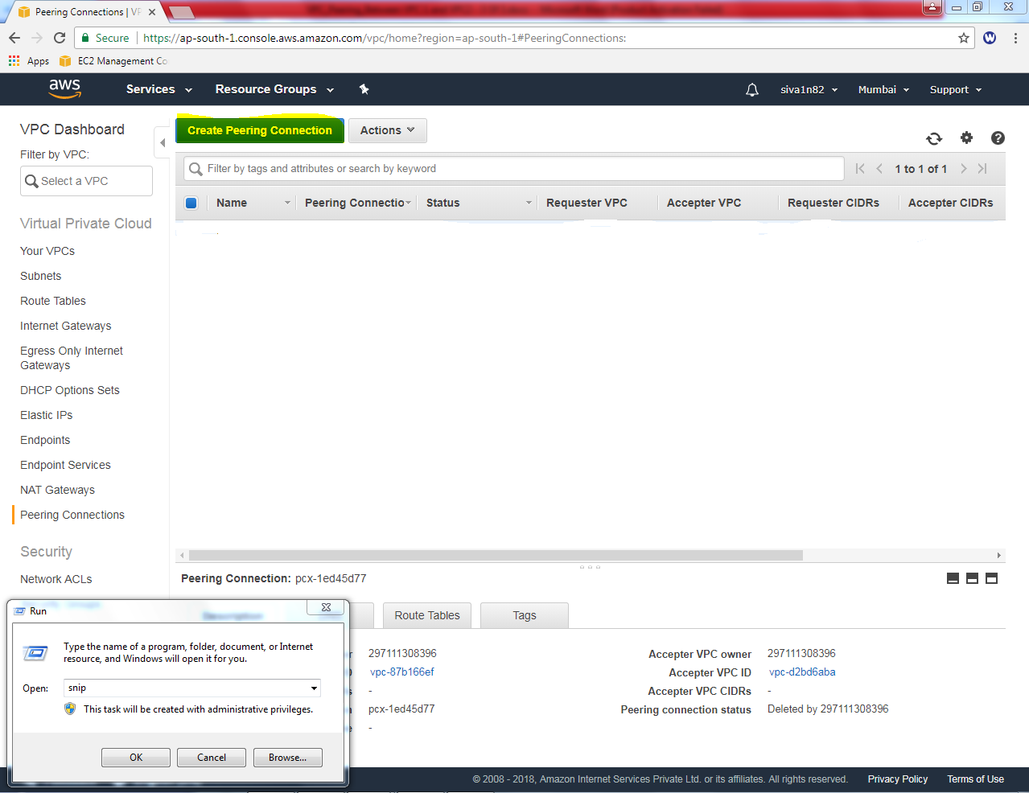

In Peering connection,

Peering Connection Name tag: vpc-peer-VPC1_and_VPC2

**VPC Requestor (Select – VPC1)**

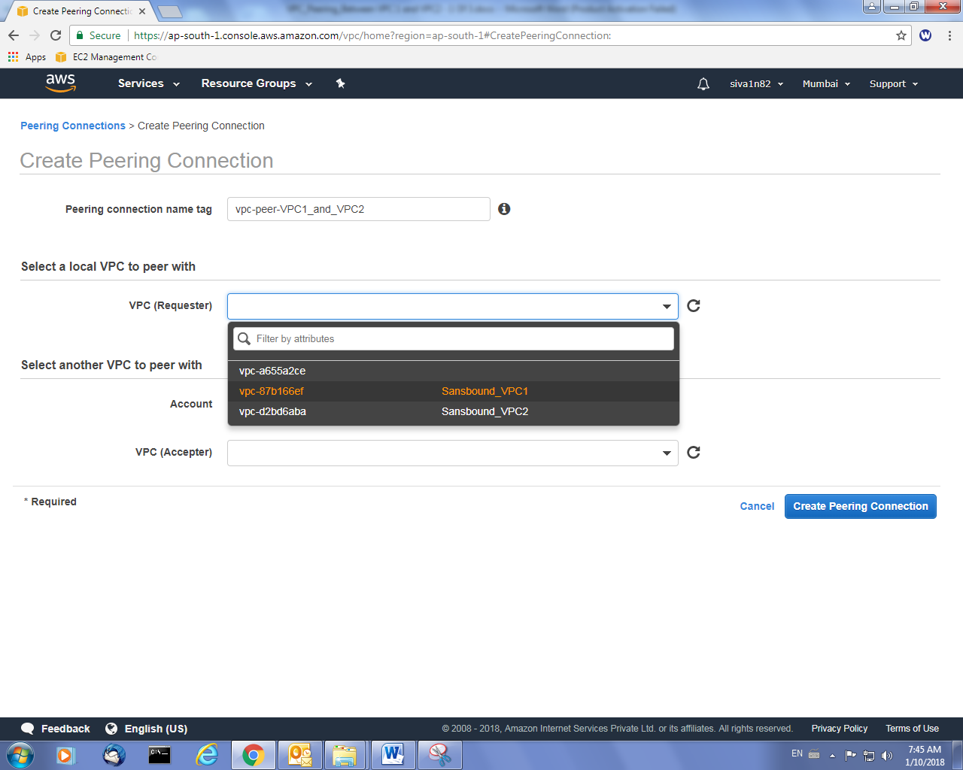

VPC Accepter “Select VPC2”

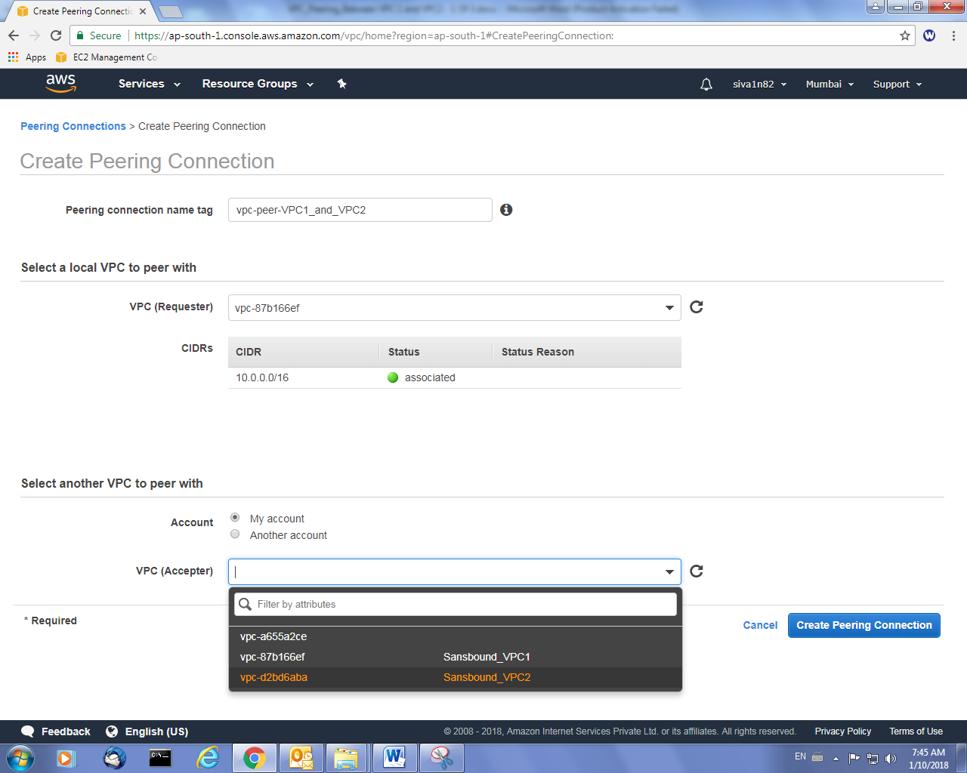

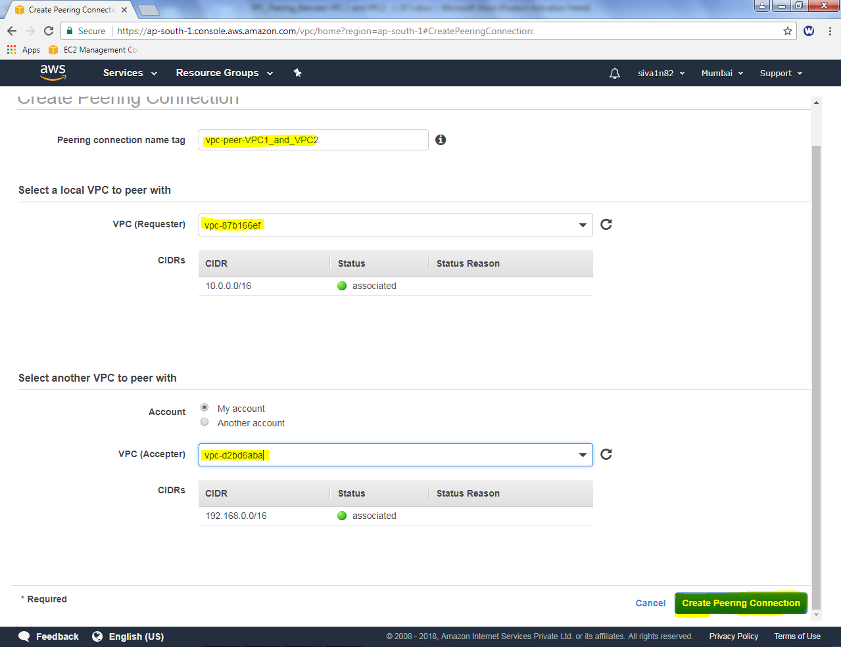

Click “Creat peering Connection”.

VPC Peer configured successfully.

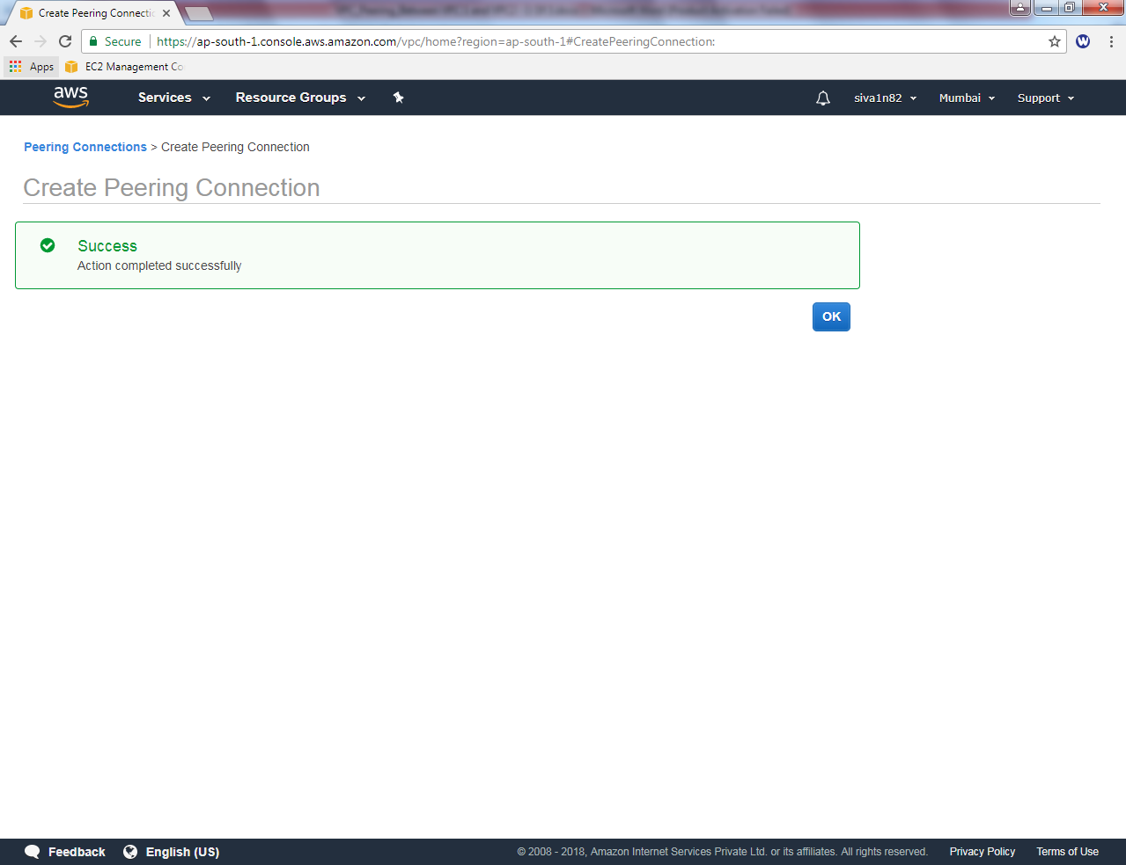

Goto Mumbai, peering connection, “Click Accept”

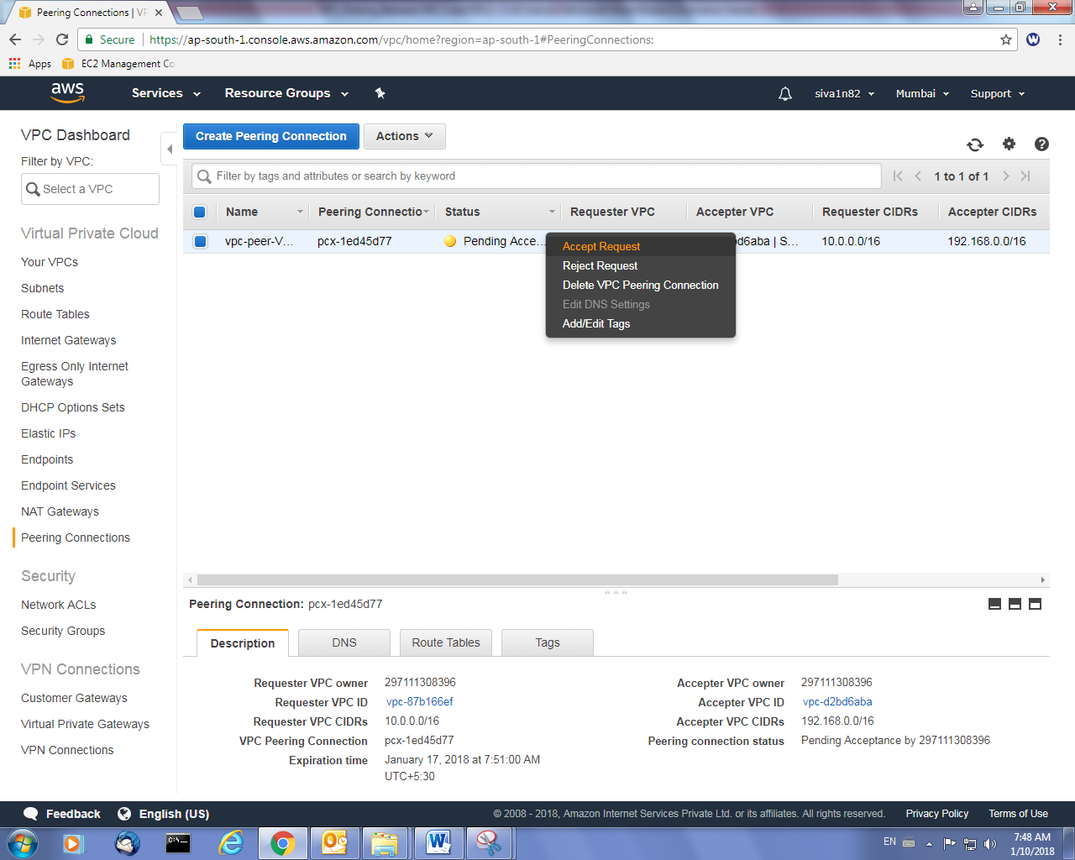

Then Click “Yes, Accept”.

Now VPC peer is active.

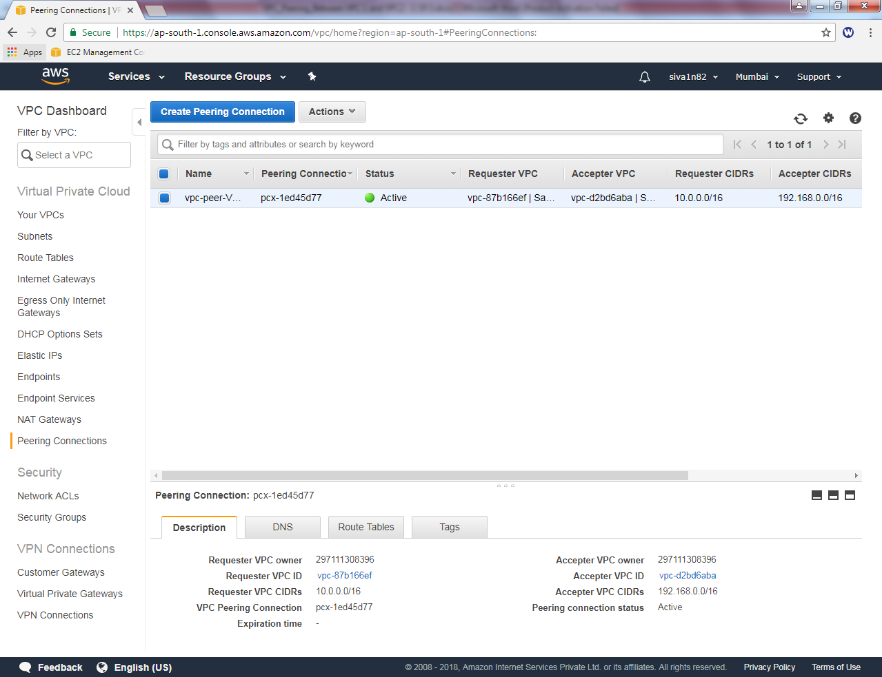

Now, you can try RDP for VPC2 subnet from VPC1 subnet. You are not able to get RDP. Because you need to add VPC2 subnet in VPC1 Public route table.

In Route tab, click “Edit”.

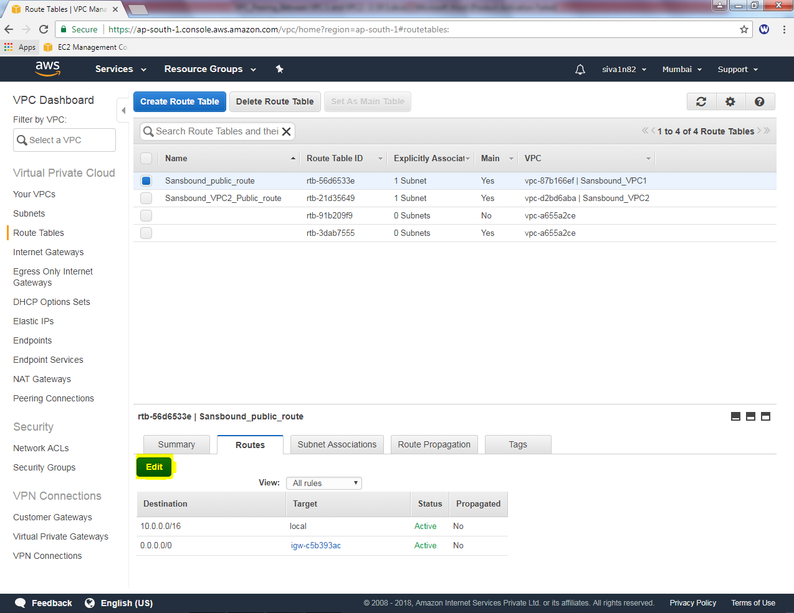

Click “Add another route”.

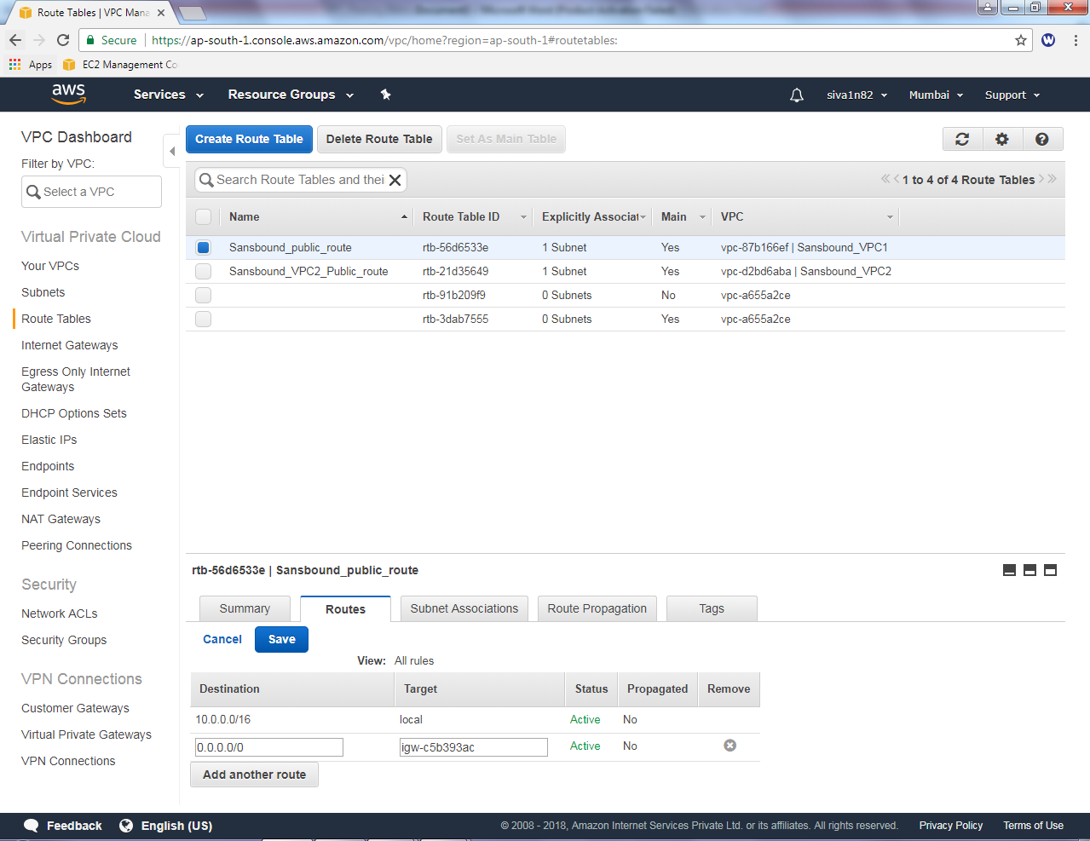

In VPC1, public routing table add 192.168.0.0/16 (VPC2) subnet and select **“pcx-*”**

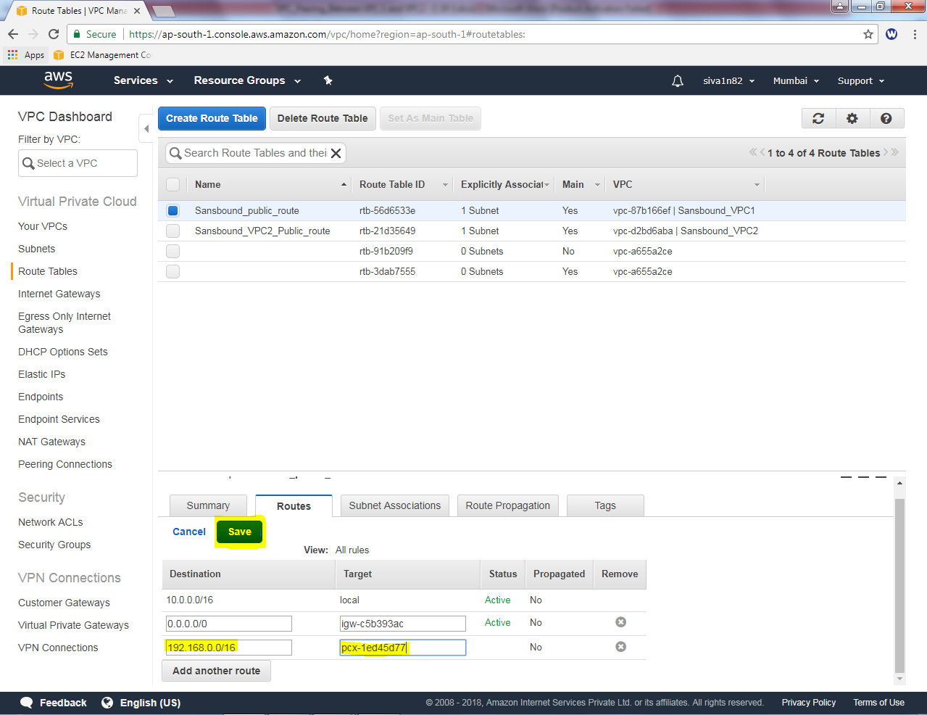

Click “Save”.

Click sansbound_VPC2_public_route table, select “Route “tab and then click “Edit”

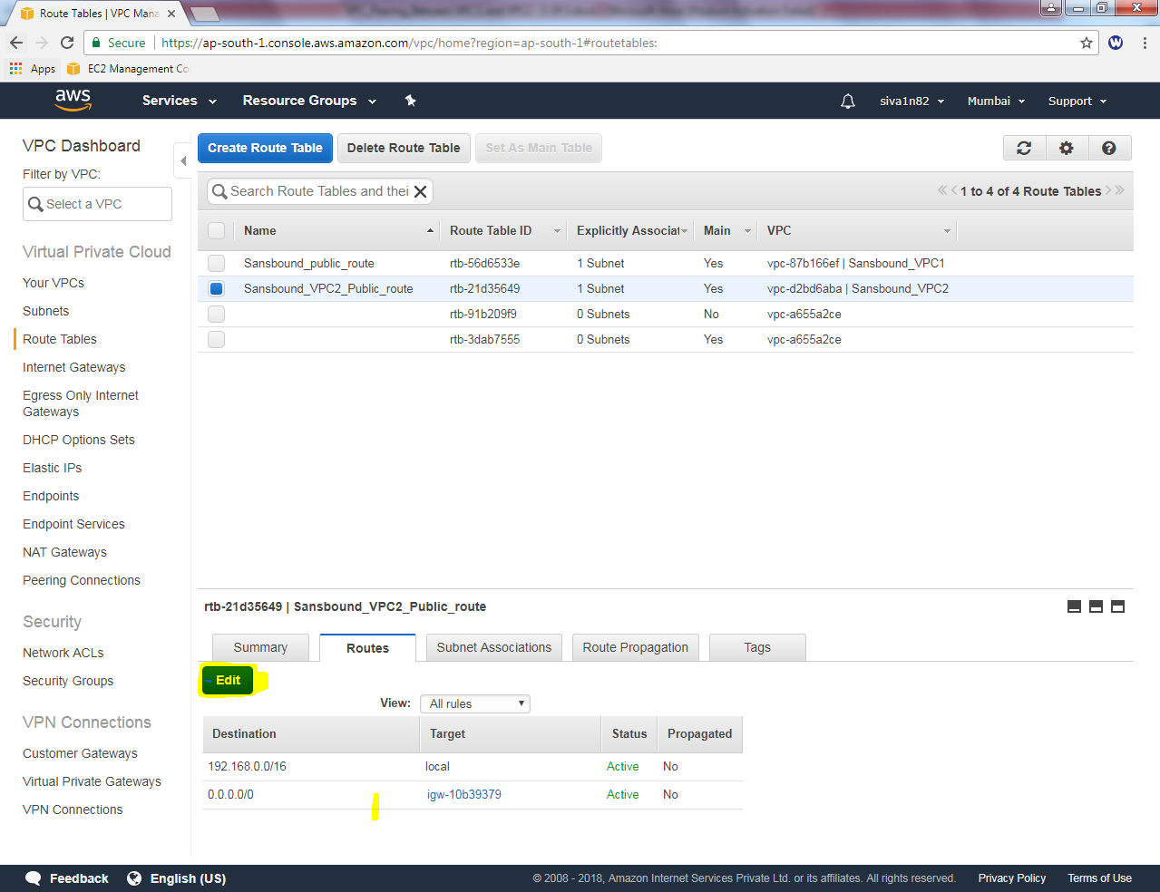

Click “add another route”

Then add 10.0.0.0/16 (VPC1) subnet and select “pcx-*”.

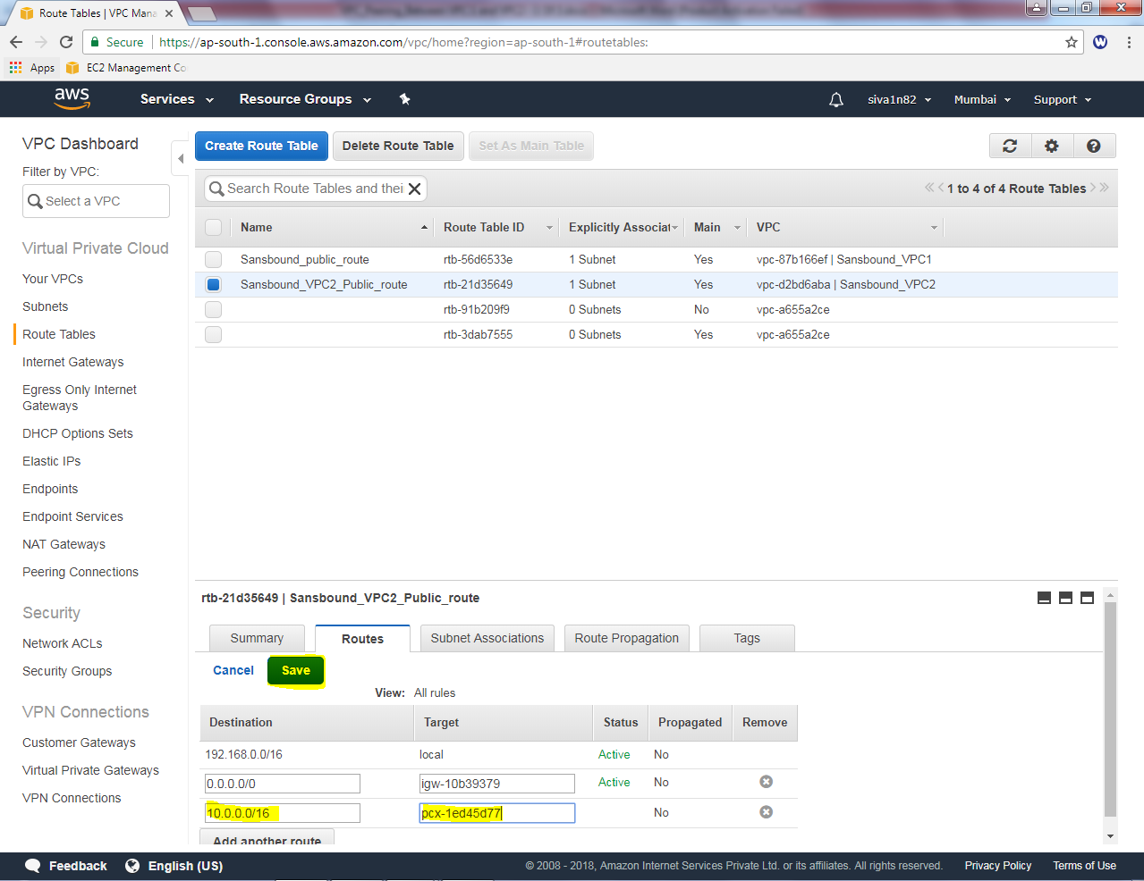

Then click “save”.

Now try to connect VPC2 private subnet from VPC1 private subnet. You will get RDP for VPC2 private subnet.

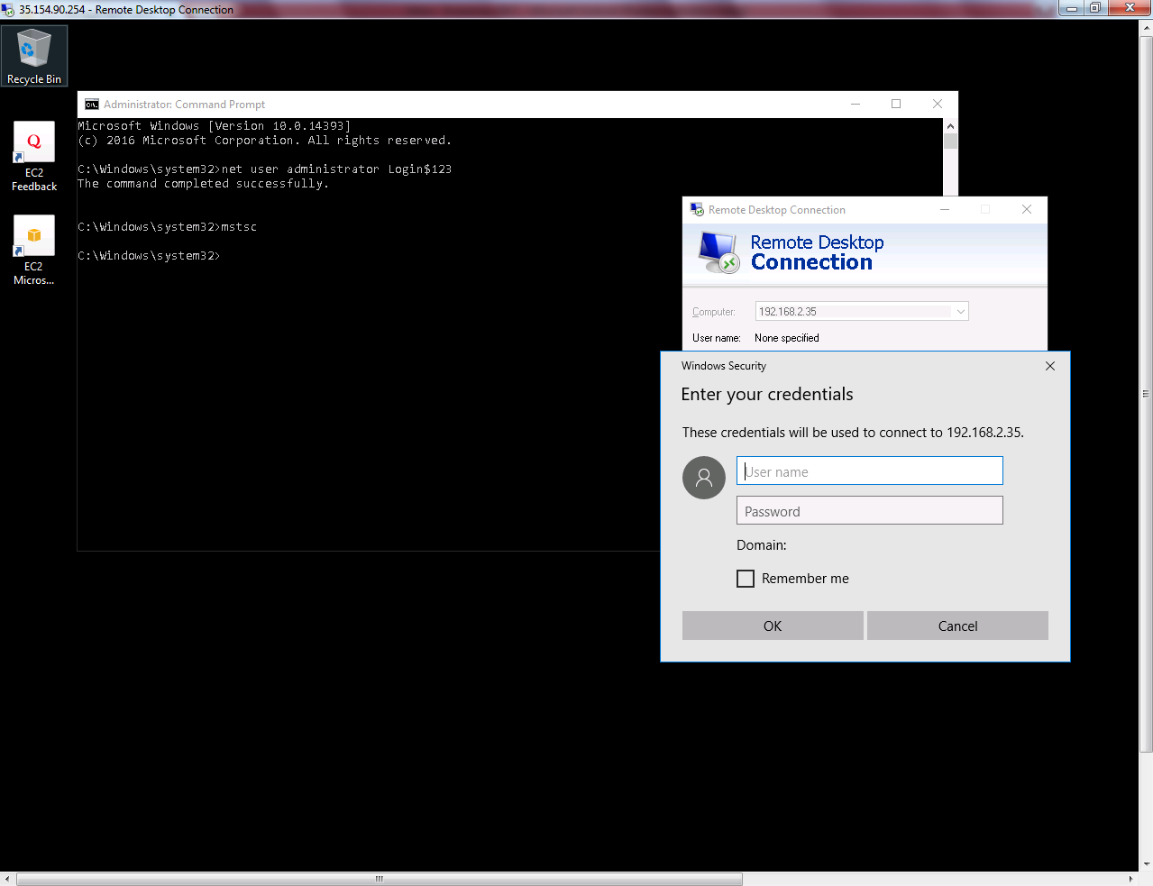

Now try to ping 192.168.2.23 (VPC2 host IP) from VPC1 Host. You will get request timed out, because ICMP was not permitted on VPC2 Security Group. RDP Port only permitted by default.

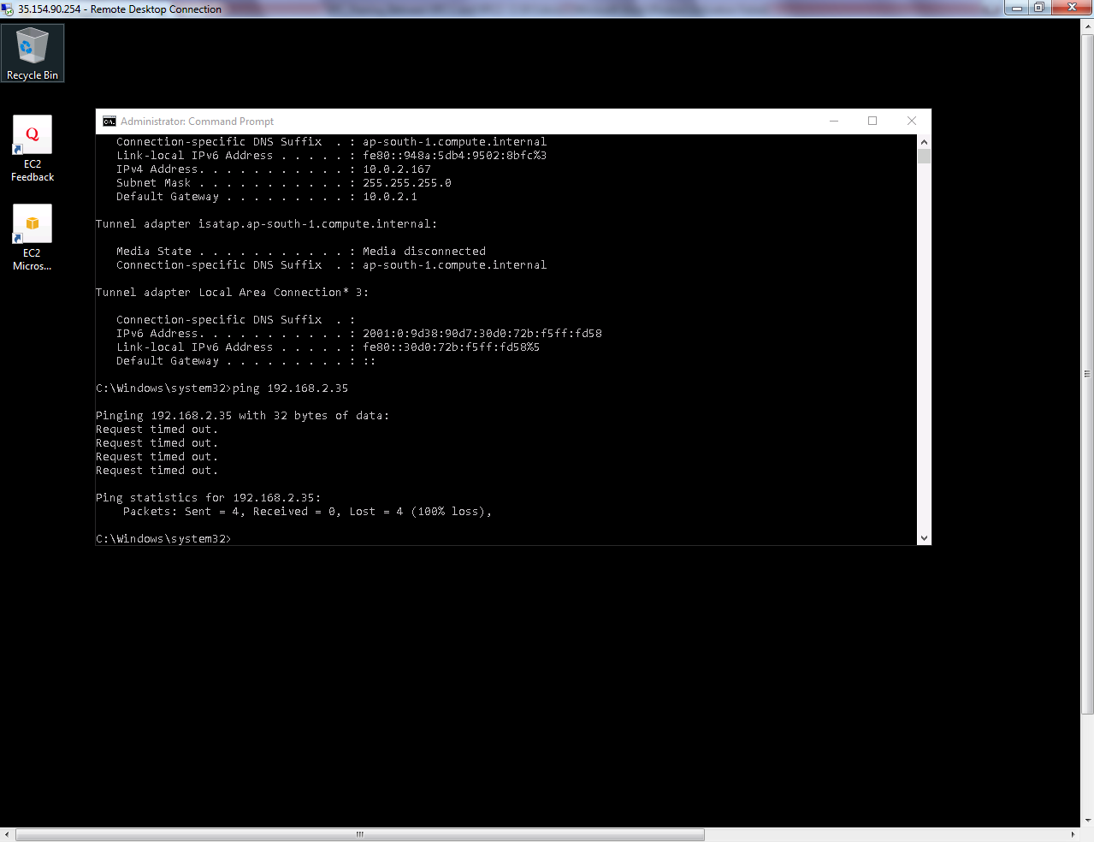

Now try to ping 10.0.2.167 (VPC1 host IP) from VPC2 Host. You will get request timed out, because ICMP was not permitted on VPC1 Security Group. RDP Port only permitted by default.

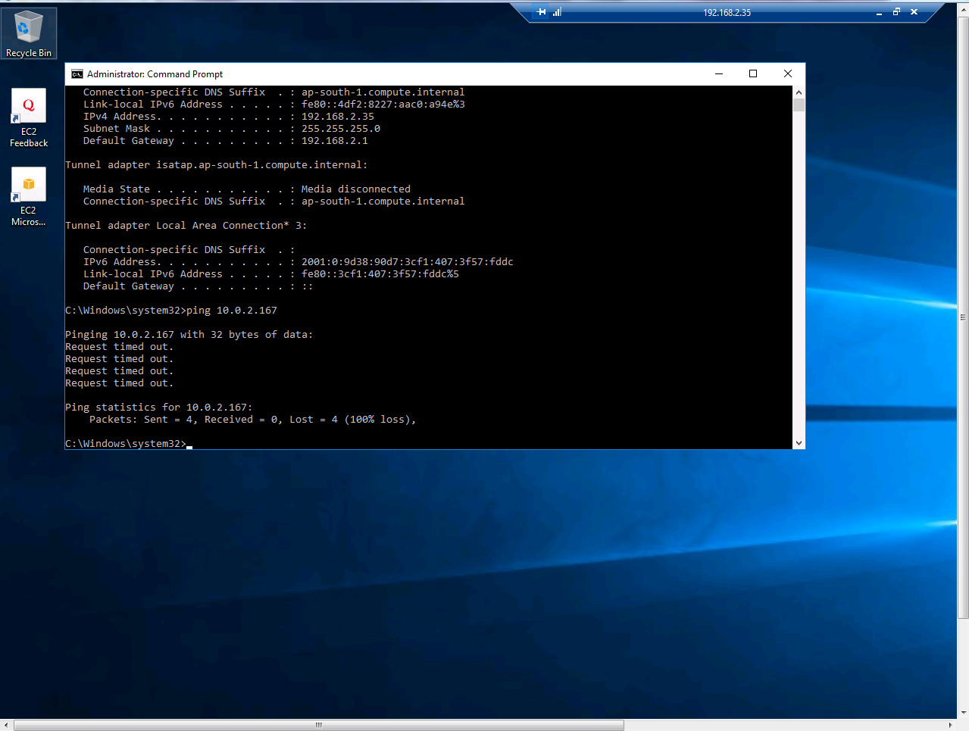

Go to “VPC1_public_sec-group” in Inbound Tab, click “Edit”.

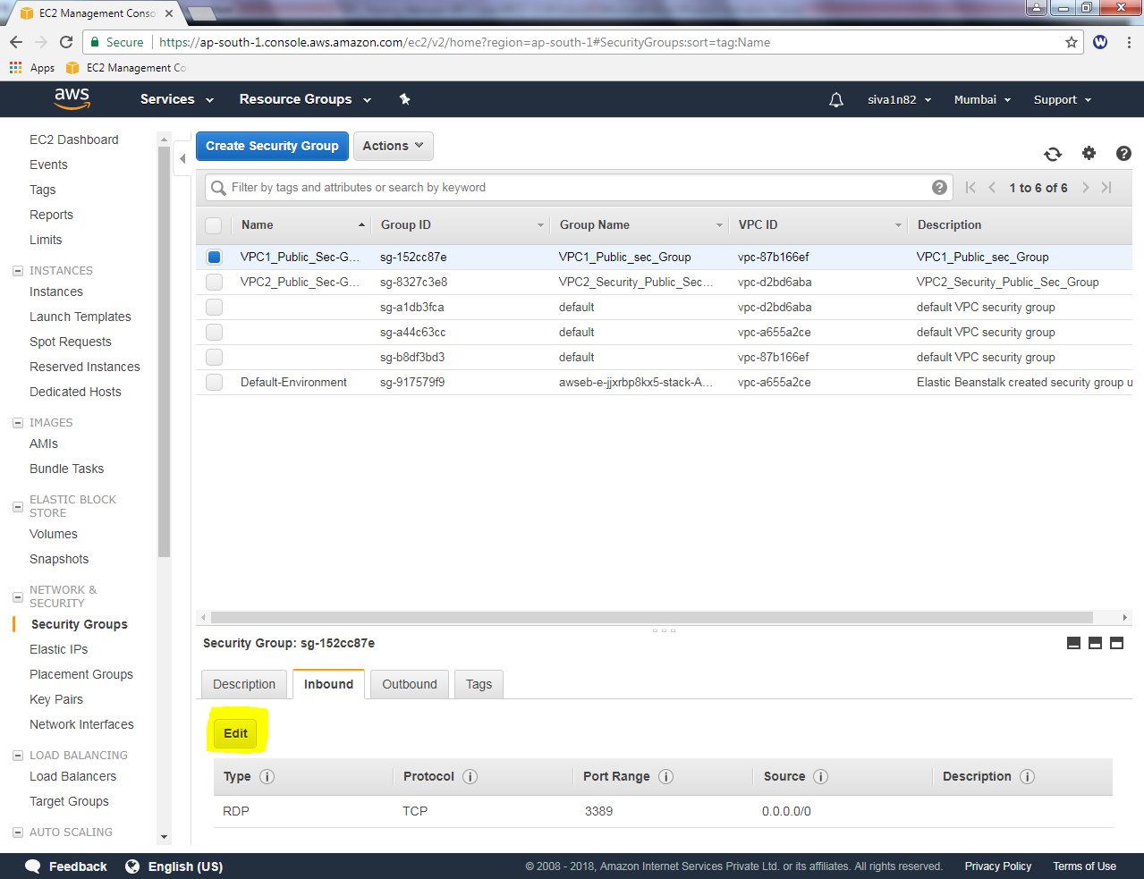

Click “Add rule”

Select “Custom ICMP” and select protocol as “Echo Request” then type source as 0.0.0.0/0

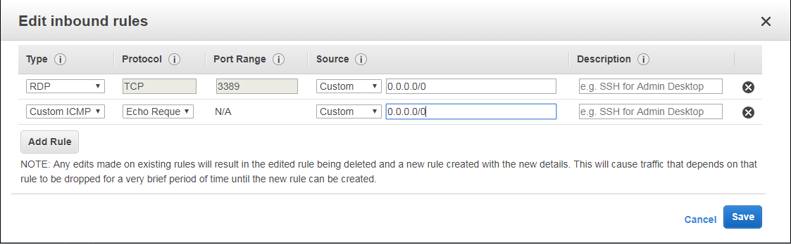

Then click “save”.

Go to “VPC2_public_sec-group” in Inbound Tab, click “Edit”.

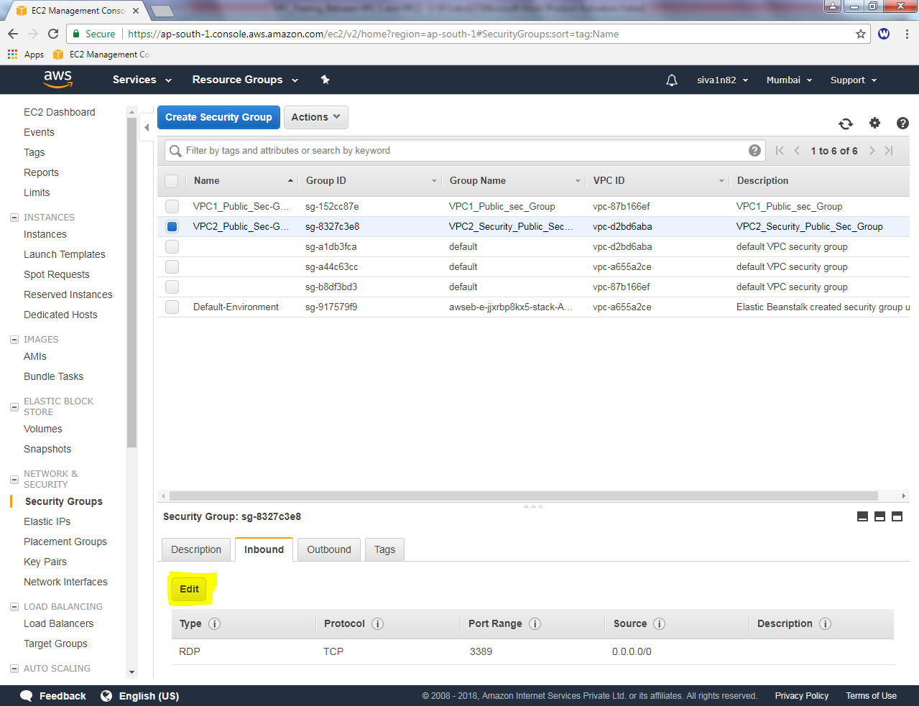

Click “Add rule”

Select “Custom ICMP” and select protocol as “Echo Request” then type source as 0.0.0.0/0

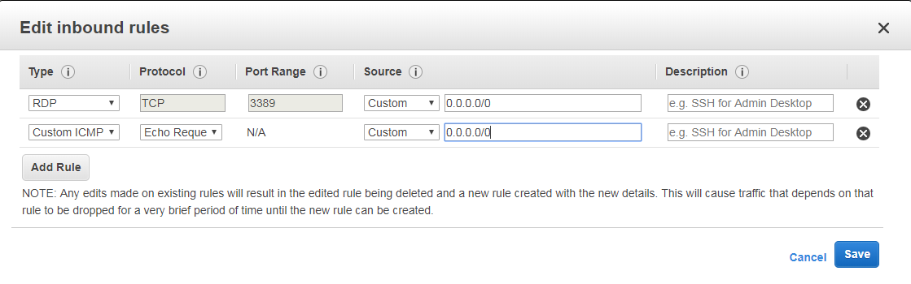

Then we need to turn off windows firewall on both servers on VPC1 and VPC2.

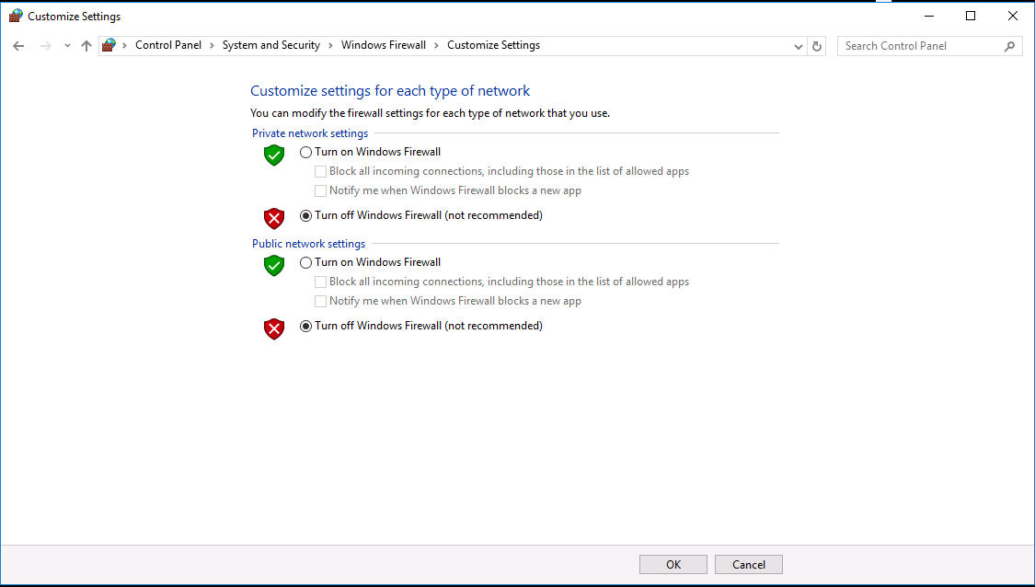

Then try to ping 192.168.2.35 host from 10.0.2.167 with successful reply.

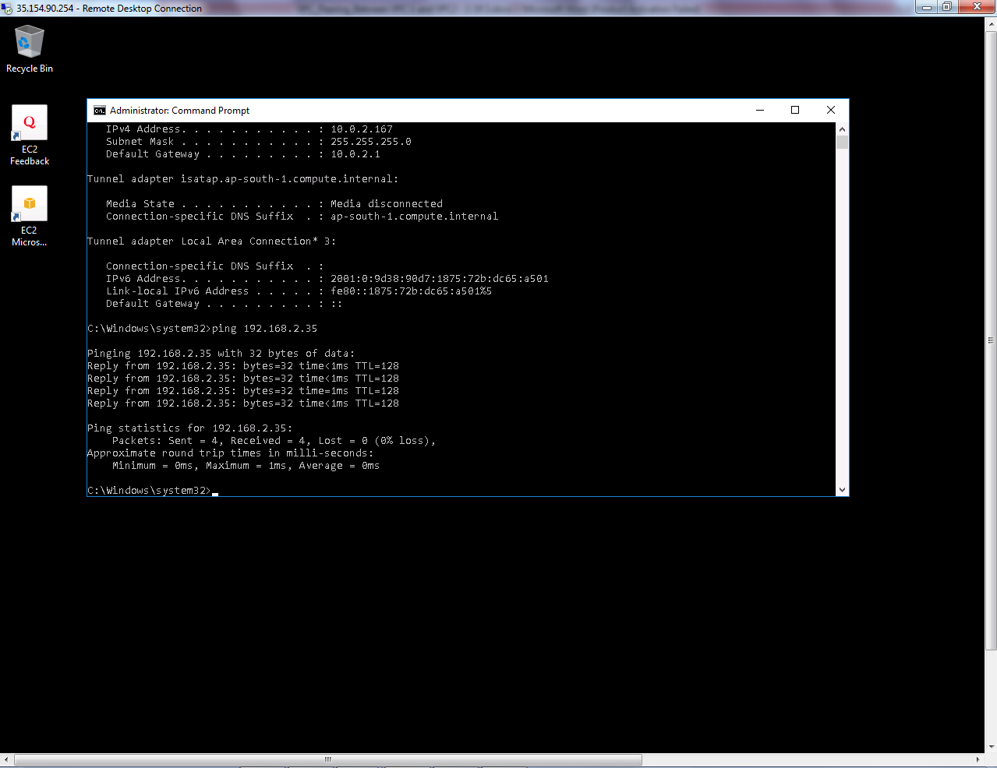

Try to ping 10.0.2.167 from 192.168.2.35 host with successful reply.

